MICROECONOMIC PROBLEMS

CLASS #10, 10TH OF MAY 2005

Problem 1
There are six participants in a THE ONLY CHANCE™ show. Their utilities might be approximated by the following functions:

UTILITY FUNCTION | INITIAL WEALTH | APPROACH TO RISK
Mr. AAA – U(W)= W^{0,5} | 1000 | ………………………
Mr. BBB – U(W)= ln(W) | 2000 | ………………………
Mr. CCC – U(W)=W² | 100 | ………………………
Mr. DDD – U(W) unknown | no data | risk averse
Mr. EEE – U(W)=W | no data | risk neutral
Mr. FFF – a rational person | no data | no data

- Which of the players is a gambler and which prefers to play it safe? How do we know that?
- The first game: Mr. AAA and Mr. CCC are faced with the following problem. They are offered participation in the show, where they are always allowed to chose between two gates. One of them hides the price of 5000, while the other has nothing to offer. Obviously they do not know which is which. If one (or both of them) decide not to play, a compensation of 500 is given. Which of the players will prefer to play and which will settle for the compensation? Give your solution graphically and analytically.
- Mr. DDD can choose between the following games:
  - Game 1 – three gates and prizes of respectively 0, 500 and 1000.
  - Game 2 – two gates and prizes of respectively 100 and 900.
Which of the games will he choose and why?
- Mr. FFF was confronted with the following choice.
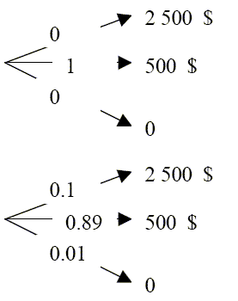

Lottery 1

Lottery 2

He chose the first lottery of the two. In the second round of the competition he may be choosing from the following options:

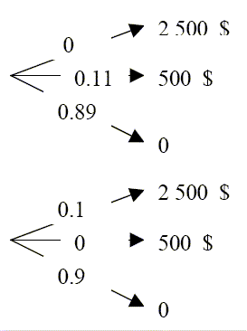

Lottery 3

Lottery 4

If he is a rational consumer, which of the lotteries in the second round will he chose?

- Mr. BBB has already won 1000. In the second round he chooses among three gates. Behind two of them there is 5000 waiting for him. If he guesses any of them he keeps his 1000 and gets this additional 5000. However, if his choice falls to the third gate, not only does he win nothing, but also has to return 1000 he has won earlier in the show. Will he participate?
- Mr EEE faces the final stage of the game. He had the choice between three gates (A, B and C). One of them has the toaster, the other 1000 000 and the last one hides the bad luck. Mr. EEE chose the gate C. The host of the show has already opened the gate A and it turned out there was a toaster hidden. Mr. EEE gets another chance to choose – he can revoke his initial choice of C and still pick B if he wanted to. What will he do? You know that he does probability at work and in life…

Problem 2
Tony has located his savings in a dot.com. If he is right, in a year he should have 81$. However, if he is not right, his shares will only be worth 9$. He estimates that he can be wrong and right with the same probability. His utility function is a logarithm of wealth with the base of 2. For how much would he be willing to sell his shares?

Problem 3
Marcus has the utility function in the form of wealth natural logarithm. For the time being he owns 50$ and wants to bet on the winning of the Polish bridge team in the World Championships. One coupon costs 10$. If the team actually wins, the bookies will pay out 20$. He estimates the probability of winning to be at 0,8 level. Will he bet?

Problem 4
Harry lives on the edge. His utility is best described by 0.001*M², where M denotes wealth. Every year our risk loving Harry buys a charity coupon in his neighborhood. With the probability of 0.005 one may win 10 000 there! The coupon (for the charity…) costs 10, while to be able to actually participate in the lottery one needs to buy also the entry to the charity party near the Christmas time. Find the maximum price he will pay for the entry as a rational consumer (no charity…), taking into consideration he already owned 10 000 before he has to decide about the lottery.

Problem 5
(Not really for solving – you do not need to be giving out your answers in public).
You have 100 and you think about participating in a certain type of game. There are cards to be drawn and if you happen to draw the Queen of the Hearts, you loose. For the matter of fact, any heart gives you a loss. Betting 1 you may win additional 0.40 (and your initial bet). Similarly, loosing means loosing the 1 you bet.
- Will YOU participate?
- If so, HOW MUCH will you bet?
Basing on these answers, are you risk averse, neutral or loving?

